Goals:

* ~~Re-tighten arms of Blam Bot~~
* ~~Replace HEX nuts with Nylock nuts of Blam Bot~~
* Add a back clamp to the back of Blam Bot

Today, Andrew and Cyrus attended the meeting.

Andrew discovered that one of the wheels was not turning smoothly. The axle was in the motor, but the axle was not spinning the motor. When he took the motor apart, he found that one of the screws connecting the motor to the chassis was damaged and so the axle could not correctly go into the motor. The motor was pressed onto the chassis. Cyrus replaced the motor and added connected the axle to it, making the wheel spin smoothly again.

Andrew tested the GPS sensor. He attached it to the Moby Green and removed its arm mechanisms as its drivetrain was only needed. We still had Moby Red with arm functionality. He calibrated the GPS sensor and learned how to read the robot’s position on the field with its coordinates. He was able to make the robot turn to specific headings to and move to specific positions.

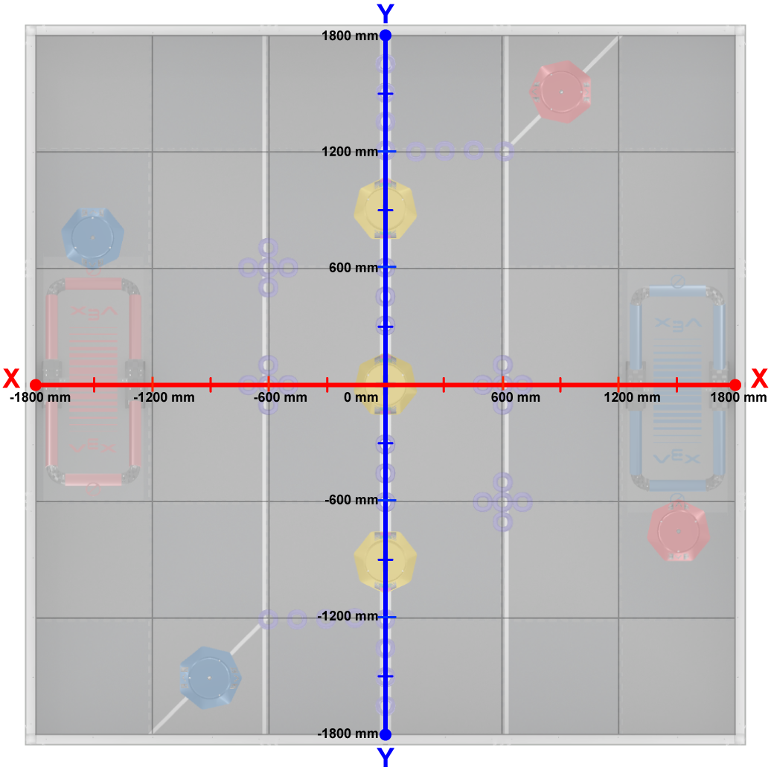

Coordinate grid of the game field